

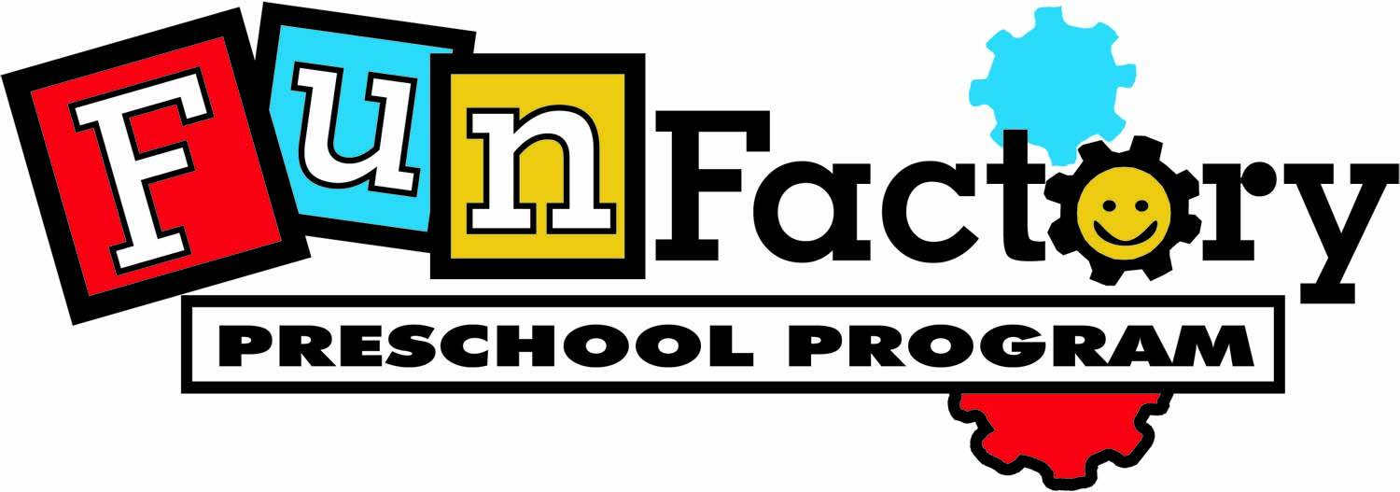

2018 / 2019

2023 - 2024

Parent Handbook

The City of Folsom Parks and Recreation Department operates the Fun Factory Preschool Programs. The mission of the Fun Factory Preschool is to provide a fun, safe, and structured nine-month preschool program that strives to offer fun recreational and educational activities in a positive learning environment. The Fun Factory allows each child opportunities to play and explore independently, as well as involve them in group activities that encourage interaction with others in the classroom. The curriculum offers opportunities for social, emotional, cognitive, physical, and creative growth that will help better prepare children for kindergarten and a lifelong love of learning.

WELCOME to Fun Factory Preschool

General Information

Fun Factory Locations: Folsom Community Center, 52 Natoma Street
Andy Morin Sports Complex, 66 Clarksville Road

Hours: 9 a.m. - noon
4-year-olds - Monday, Wednesday, and Friday
3-year-olds – Tuesday and Thursday
3 Day a Week 3-year-olds – Monday, Wednesday, and Friday

Phone: Community Center Classroom 916-461-6621 (Ms. Michelle)
Community Center Cell Phone 916-496-2002

Sports Complex Classroom 916-461-6667 (Ms. Prati)
Sports Complex Cell Phone 916-496-2006

Whitney Kahn
Recreation Coordinator II
916-461-6612
wkahn@folsom.ca.us

Parks and Recreation Main Office 916-461-6601

Program Dates: August 28th or 29th, 2023 to May 22nd or 23rd, 2024

Program Closure Dates:
(Fun Factory Preschool program follows the FCUSD holiday dates)
September 4 Labor Day
November 10 Veteran’s Day
November 20 - 24 Thanksgiving Break
December 18 – Jan 1 Winter Break
January 15 Martin Luther King Jr. Day
February 19 & 20 President’s Day & Lincoln’s Birthday (observed)
March 25-March 29 Spring Break

Fees:
4-year-olds: $309 - $299 Resident Discount (Must be 4 years old by 9/30/23)
3 Day a Week 3-year-olds: $309 - $299 Resident Discount (Must be 3 years old by 9/30/23)
3-year-olds: $235 - $225 Resident Discount (Must be 3 years old by 9/30/23)

$100 non-refundable yearly registration fee

Tuition: When you registered your child for preschool, you were set up for automatic billing.
- Automatic Billing – We will process your payment on the 25th of the month for the following month’s tuition. Automatic billing will start on September 25th and will continue monthly through April 25th to cover May’s tuition.
- If you remove your child from the program for any reason, and then would like to return to our program, you will need to pay a new $100 registration fee.

Emergency Information/procedures: Parents must fill out emergency information in our HIPAA compliant cloud based system, ePACT. It is the parent’s responsibility to update their information in ePACT should anything change throughout the school year. If your child is injured, 911 will be called for emergency medical assistance. Anyone picking up your child must be listed in ePACT and must be prepared to show identification.

Clothing: Children need to dress in clothing suitable for messy art projects and vigorous play. Closed toed shoes are required: sandals, flip-flops, and slick-soled shoes are not permitted. Please print child’s names inside all removable clothing.

Arrival and Departure – Cell Phones Off Please
- The preschool teacher wishes to be fully prepared for the day. Therefore, the door will remain closed prior to the start time of class.
- Always sign in your child when arriving and sign out when leaving. The safety of your child is our primary concern.
- Please try and notify a teacher in advance if someone else is picking up your child. Anyone picking up your child must be listed on the Child’s Emergency Form and must be prepared to show I.D. If for some reason a parent was not able to notify classroom staff ahead of time, staff will attempt verification over the phone. Parent must send an email to the recreation supervisor or preschool specialist explaining that authorization was given over the phone.
- We will assess a late charge of $1 per minute if child is not picked up by 12:05p.m. Notice will be given to the parent when a late charge will be assessed.

Parking Lots: Please be aware when coming and going through our parking lots where our preschools are located. Please hold your child’s hand when going through the parking lot. Many patrons come into these parking lots not knowing that there is a preschool program at this facility.

Andy Morin Sports Complex: Please note that the Andy Morin Sports Complex has a drop-in fee for use of the basketball courts and soccer fields. At the request of the Andy Morin Sports Complex Management, please do not allow your child to run on the basketball court before and after class. Thank you for your understanding on this Andy Morin Sports Complex Policy.

Stairs and wall near City Hall: Many kids before and after school at the Folsom Community Center love to run up the stairs and down the handicap ramp. Please remind your child not to scream when doing so, as city offices are located in that same area. Please also keep your child from walking across the wall at the edge of the flowerbed and handicap ramp. We do not want them to fall off of the wall.

Separation: It is often difficult for both parent and child to get through the first few days of school. We know that it’s a big step. If you anticipate tears or other expressions of anxiety, may we offer a few suggestions based on experience from our preschool teachers:
- Attend open house with your child.
- Make sure your child knows when school is over and who will pick him/her up.
- Express your own enthusiasm about school.
- Don’t linger… we know it’s hard, but children usually stop crying and get involved in activities minutes after their parents leave.
- Always say goodbye to your child… do not sneak out!
- Please know that we will call you if your child continues to cry and we can’t settle him/her down in a timely fashion.

Monthly Schedules: Every month parents are provided with a calendar and newsletter for information on lesson topics. A thematic approach is used in lesson planning where each day’s activities are woven around that theme.

Daily Schedule: Though the schedule varies, an example of a typical day is as follows:
- Carpet Time - calendar, jobs, themes, letter of the week
- Small group stations – math, science, fine motor skills, language arts
- Arts and Crafts
- Social Time
- Carpet Time - story/snack time
- Exercise Time
- Carpet Time - music, story, Star of the Week

Snack: Parents, please send a healthy snack and drink daily with your child to preschool. An example of a snack would be a juice box/water bottle, carrots, and fruit snacks. Please do not send a full lunch. When packing your child’s snack, please consider the following things: can my child open this by themselves; is it easy to eat, will my child even like this? We would like to discourage items such as Go-Gurts. These tend to end up more down the front of the child instead of in their mouth.

Teachers will remind students that they can only eat food that was packed for them and in their lunch and will not be allowed to share their snacks with other students, due to allergies, etc… It would also be helpful if you also have a conversation to remind your student that they should not eat others lunches, nor share their lunches with their classmates.

OUR CLASSROOMS ARE PEANUT/NUT FREE. Please help us by not sending any peanuts or nut products with your child. Thank you for your understanding on this subject.

Toys and Other Items from Home: Please note that toys from home are not allowed in preschool. They end up getting lost with our toys or accidentally broken by other students. When it is your child’s turn to be Star of the Week, this is the appropriate time to bring in items from home. Thank you for your understanding.

Illness/Absences: Children will not be allowed in preschool if they are ill, have head lice, or any other communicable illness. Children must be free of all symptoms for 24 hours before they will be permitted to return to preschool. Preschool staff has the authority to refuse any child who shows signs of illness. If your child becomes ill or injured, the parent will be called, and your child must be picked up within one hour. No credits will be given toward tuition due to illness or vacation. It is the parent's responsibility to notify the school when their child is ill and to check with a teacher regarding future events.

Teachers and children are concerned when a child is missing from school. Please notify your child’s teacher if they will be missing class.

Discipline Policy: Providing the children with a safe, fun, and exciting program will reduce the opportunities for discipline problems. However, sometimes discipline problems will become an issue, and our staff will always use positive reinforcement to encourage good behavior. Teachers will always try redirecting first, and will encourage the student to take a break if the redirection isn’t working. If a child continues to have difficulties, a phone call home or a Communication Form may be sent home, and a parent conference may be scheduled if needed. Our preschool programs have a NO BITE Policy, one warning will be given.

Parent/Teacher Conferences: Individual parent/teacher conferences may be conducted per the request of either parent or teacher during the entire school year. If you would like to request a conference with the teacher, you may do so by contacting your child’s teacher. Our four-year old classes will schedule end of the year conferences for each child. These conferences are generally scheduled in the late spring.

The first month of preschool will give the teacher a chance to evaluate all students to determine if they are ready for the program. If the teacher feels the student is not ready, a parent/teacher conference will be conducted to help determine if the student should remain in the program.

Field Trips: Occasionally, the class will go on Field Trips. Parents must transport their own child or make arrangements to carpool with a friend from the class to the field trip. We request that you please make other arrangements for siblings, as this is a special day to share with your child in the class.

Toilet Training: All students are required to be toilet trained by the first day of class. Toilet trained means that the child wears underwear (not pull-ups) and can attend to his/her own bathroom needs, including wiping. If a problem arises, such as an accident, the teacher will contact the parent to come and bring a change of clothes. After three accidents, your child will be removed from the program.

Bathroom Breaks: We have one group bathroom break right before snack time. However, we know that at anytime, a child may ask to use the bathroom. Whenever a teacher may be taking someone to the bathroom, they will ask if anyone else may need to go as well. Teachers will always accompany the students to and from the bathrooms, as well as do a quick check before going in to make sure no one else is in the bathroom. Each child is expected to attend to his/her own needs. Teachers will help the kids with clothing, washing their hands, and if they need assistance on and off the toilet. Teachers will not assist with wiping. We also have step stools if needed. It would help the teachers out if you were to take your child to the bathroom prior to entering the classroom if possible. We spend a lot of time taking bathroom breaks. Please dress your child in easy clothes for them to take down and up. Belts and overalls are not recommended since children have a hard time with these items.

Birthdays: We are happy to help your child celebrate his/her birthday with their classmates.
Please check with your child’s teacher ahead of time. This helps to make sure those with food allergies are notified and can bring in something special as well to enjoy on that day. Also, please do not pass out party invitations during school hours unless the entire class is invited. There are many hurt feelings when someone is left out.

Withdrawal from school: Please notify the Preschool Director, as well as your child’s Preschool Teacher, if you will be withdrawing your child from the program.
A two-week notice in writing is required when removing your child from the program.

Community Center Classroom 916-461-6621 (Ms. Michelle)
Sports Complex Classroom 916-461-6667 (Ms. Prati)

Whitney Kahn
Recreation Coordinator II 916-461-6612 wkahn@folsom.ca.us

Parks and Recreation Main Office : 916-461-6601
Communication from the main office email system will come through as: practivity@folsom.ca.us

