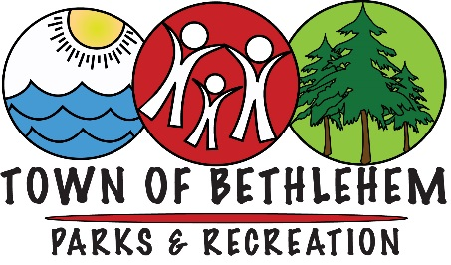

Discovery Day Camp
NOT bringing medication to camp

Child’s Name:________________________________ DOB:__________

The above named child will NOT be bringing any medication to Discovery Day Camp which includes (but is not limited to) prescription medication, over the counter medication, epi pens or inhalers.

Parent/Guardian Signature:____________________________ Date:______

