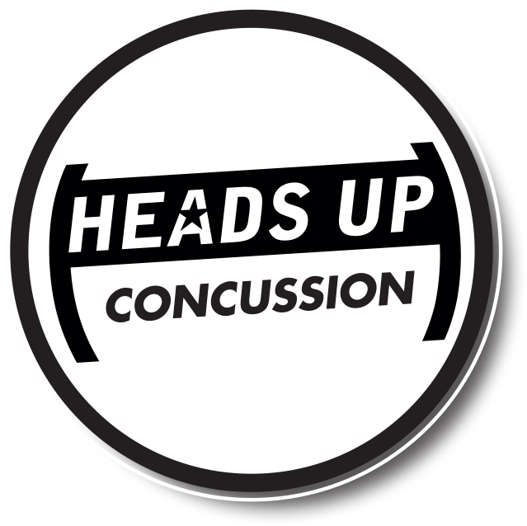
Participants Name (print): DOB:

CONCUSSION FACT SHEET FOR PARENTS

WHAT IS A CONCUSSION?
A concussion is a type of traumatic brain injury. Concussions are caused by a bump or blow to the head. Even a “ding,” “getting your bell rung,” or what seems to be a mild bump or blow to the head can be serious.

You can’t see a concussion. Signs and symptoms of concussion can show up right after the injury or may not appear or be noticed until days or weeks after the injury. If your child reports any symptoms of concussion, or if you notice the symptoms yourself, seek medical attention right away.

WHAT ARE THE SIGNS AND SYMPTOMS OF CONCUSSION?
If your child has experienced a bump or blow to the head during a game or practice, look for any of the following signs of a concussion:

SYMPTOMS REPORTED BY ATHLETE:
- Headache or “pressure” in head
- Nausea or vomiting
- Balance problems or dizziness
- Double or blurry vision
- Sensitivity to light
- Sensitivity to noise
- Feeling sluggish, hazy, foggy, or groggy
- Concentration or memory problems
- Confusion
- Just not “feeling right” or is “feeling down”

SIGNS OBSERVED BY PARENTS/ GUARDIANS:

- Appears dazed or stunned
- Is confused about assignment or position
- Forgets an instruction
- Is unsure of game, score, or opponent
- Moves clumsily
- Answers questions slowly
- Loses consciousness (even briefly)
- Shows mood, behavior, or personality changes

[ INSERT YOUR LOGO ]

DANGER SIGNS
Be alert for symptoms that worsen over time. Your child or teen should be seen in an emergency department right away if s/he has:
- One pupil (the black part in the middle of the eye) larger than the other
- Drowsiness or cannot be awakened
- A headache that gets worse and does not go away
- Weakness, numbness, or decreased coordination
- Repeated vomiting or nausea
- Slurred speech
- Convulsions or seizures
- Difficulty recognizing people or places
- Increasing confusion, restlessness, or agitation
- Unusual behavior
- Loss of consciousness (even a brief loss of consciousness should be taken seriously)

WHAT SHOULD YOU DO IF YOU THINK YOUR CHILD HAS A CONCUSSION?
- SEEK MEDICAL ATTENTION RIGHT AWAY
A health care professional will be able to decide how serious the concussion is and when it is safe for your child to return to regular activities, including sports.
- KEEP YOUR CHILD OUT OF PLAY.
Concussions take time to heal. Don’t let your child return to play the day of the injury and until a health care professional says it’s OK. Children who return to play too soon - while the brain is still healing - risk a greater chance of having a second concussion. Repeat or later concussions can be very serious. They can cause permanent brain damage, affecting your child for a lifetime.
- TELL YOUR CHILD’S COACH ABOUT ANY PREVIOUS CONCUSSION.
Coaches should know if your child had a previous

HOW CAN YOU HELP YOUR CHILD PREVENT A CONCUSSION OR OTHER SERIOUS BRAIN INJURY?
- Ensure that they follow their coach’s rules for safety and the rules of the sport.
- Encourage them to practice good sportsmanship at all times.
- Make sure they wear the right protective equipment for their activity. Protective equipment should fit properly and be well maintained.
- Wearing a helmet is a must to reduce the risk of a serious brain injury or skull fracture.
  - However, helmets are not designed to prevent concussions. There is no “concussion-proof” helmet. So, even with a helmet, it is important for kids and teens to avoid hits to the head.

HOW CAN I HELP MY CHILD RETURN TO SCHOOL SAFELY AFTER A CONCUSSION?

Children and teens who return to school after a concussion may need to:
- Take rest breaks as needed
- Spend fewer hours at school
- Be given more time to take tests or complete assignments
- Receive help with schoolwork
- Reduce time spent reading, writing, or on the computer

Talk with your child’s teachers, school nurse, coach, speech-language pathologist, or counselor about your
child’s concussion and symptoms. As your child’s symptoms decrease, the extra help or support can be removed gradually.

concussion. Your child’s coach may not know about a concussion your child received in another sport or activity unless you tell the coach.
Participants Name (print): Parents Name (print): Parents Signature: Date:

JOIN THE CONVERSATION www.facebook.com/CDCHeadsUp
TO LEARN MORE GO TO >> WWW.CDC.GOV/CONCUSSION

Content Source: CDC’s Heads Up Program. Created through a grant to the CDC Foundation from the National Operating Committee on Standards for Athletic Equipment (NOCSAE).

